**PDF Merger User Guide**

1. Extract/Unzip the files to any location you prefer (Script might not work if the files aren’t extracted or unzipped)
2. After extracting, you should see the following files in the folder (Sample files are provided to test the script).  
   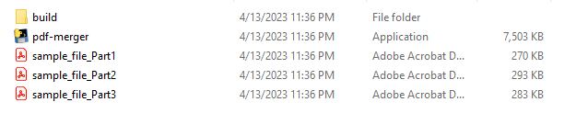
3. To use the merger, the PDF files you want to merge should always be within the same folder as the script.
4. Delete all sample files and put the PDF files you want to merge.
5. For the script to properly work, the filenames should end in “Part1”, “Part2”, “Part3”, etc.
6. Run the script “pdf-merger”.
7. If you see the prompt below, just click “More info”, then “Run anyway”.  
   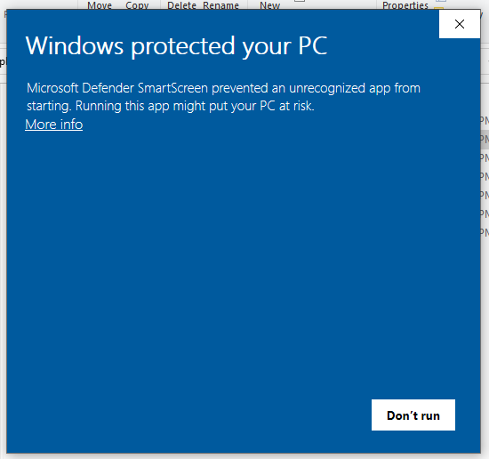
8. It should return the output called “merged” in the same folder.

For any issues with this script, please contact me: Aldrin Renz Cruz (aldrinrenzcruz@proton.me).